**What is a Mortgage?**

Most people do not have the cash to buy a home outright. They finance the home by obtaining a ______________. A mortgage is a _________ to buy _____________, with the property as security. If the buyer, or ___________, fails to make the payments, the lending institution can sell the property and use the money to pay off the mortgage.

***- Mortgagee -Mortgage - property - loan***

The home buyer is required to have a percent of the house price in _________ as a ________________. The remainder is obtained through a ____________. The buyer agrees to pay back the mortgage over a specified period of time with a ___________ of equal ____________ payments. A mortgage, therefore, is an _________.

***- number -annuity -down payment - loan - cash - amortized***

Mortgage payments are usually made ___________. Since a large sum of money is involved, the time taken to repay a mortgage usually ranges from ______ to ______ years. Mortgages in Canada cannot legally be compounded more frequently than ________________________. In the work on annuities that you have done so far, the compounding frequency has been the same as the payment interval.

When both the principal and interest on a mortgage are repaid with a series of equal regular payments, we say the mortgage is ___________________. The length of time for which a mortgage is repaid is called the _______________

***- 5 years - 40 -Monthly -20 - fixed -term***

Since interest rates change frequently, the mortgage rates are rarely fixed for the entire amortization period. Instead, the interest rate is set for a length of time called the _________ of the mortgage. The term normally ranges from ____ months to _____ years. At the end of the term, the mortgage must be paid off or _____________at the current rate of interest.

***-Term - 6 -5 - renewed***

**How to Calculate the Monthly Payment**

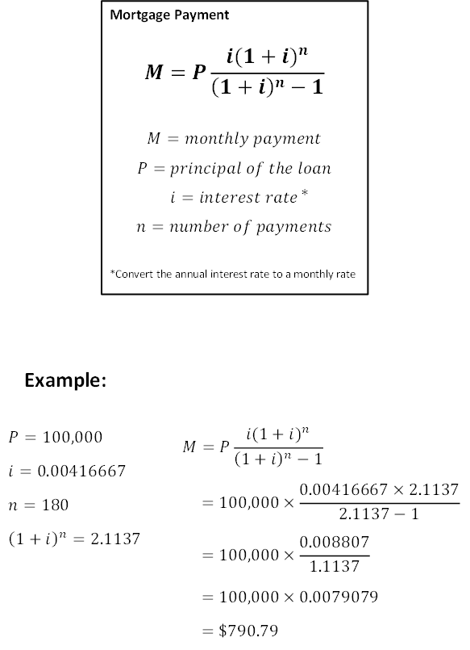

Consider a mortgage of $100,000, with compounded monthly for 15 years, with an interest rate of 5%.

Determine the monthly payment.

Determine the total interest paid.

**Examples:**

1. A mortgage of $205 000 is required to purchase a house. The mortgage will be repaid with equal payments over 30 years at 7.5% compounded monthly.

1. What is the monthly payment?
2. What is the total interest paid over the 30 years?

2. A mortgage of $190 000 is required to purchase a home. The mortgage will be repaid with equal monthly payments over 25 years at 8% compounded monthly.

1. What is the monthly payment?
2. What is the total interest paid over the 25 years?