UNIT #4
Graphical Models
MAP 4C

Unit Goals:
- Interpret graphs to describe a relationship, using language and units appropriate to the context.
- Describe trends based on given graphs, and use the trends to make predictions or justify decisions.
- Recognize that graphs and tables of values communicate information about rate of change, and use a given graph or table of values for a relation to identify the units used to measure rate of change.
- Identify when the rate of change is zero, constant, or changing, given a table of values or a graph of a relation, and compare two graphs by describing the rate of change.
- Compare, through investigation with technology, the graphs of pairs of relations by describing the initial conditions and the behaviour of the rates of change.
- Recognize that a linear model corresponds to a constant increase or decrease over equal intervals and that an exponential model corresponds to a constant percentage increase or decrease over equal intervals, select a model to represent the relationship between numerical data graphically and algebraically, using a variety of tools and strategies, and solve related problems.
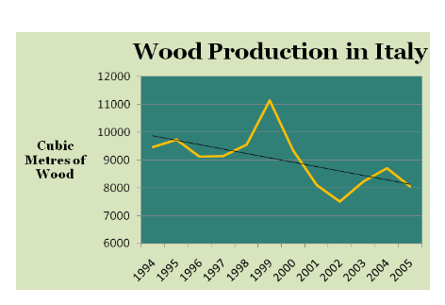
- Make connections between formulas and linear, quadratic, and exponential functions, using a variety of tools and strategies.

Discuss trends for wood production in Italy.

KEY TERMS

Trends:

Rate of Change:

First Differences:

Second Differences:

Linear:

Quadratic:

Exponential:

