OPTION # 2: A RUBE GOLDBERG MACHINE

HISTORY
Reuben Lucius Goldberg was a Pulitzer Prize-winning artist that cartooned inventions putting an elementary challenge into a complicated and convoluted series of steps. The contraptions satirised the new technology and gadgets of the day. Using simple machines and household items already in use, the complex and wacky inventions always got the job done.
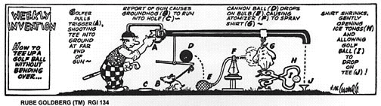
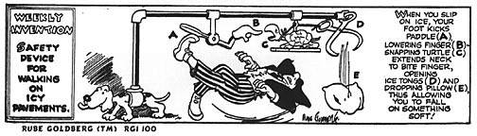
Rube Goldberg Machines have become an annual competition and a national craze. The idea of Rube Goldberg machines have appeared in video games, movies (in Back to the Future, a Rube Goldberg machine feeds Doc’s dog Einstein) and board games. In the Hasbro board game, “MouseTrap”…you start by turning the crank, that rotates the gears, that push the lever, that moves the shoe, that kicks the bucket, that sends the ball down the stairs and into the gutter, that leads to the rod that releases a second ball, that falls through the bathtub and onto the springboard, that catapults the diver into the washtub, that causes the cage to fall and--whew!--hopefully, capture a mouse.

CHALLENGE
You will design a Rube Goldberg machine to pop a balloon, water a plant, crack an egg into a frying pan (or other task that has been approved by Ms. Carew) using at least 8 steps. The machine should use at least 3 different types of energy (kinetic, gravitational potential, elastic potential), at least one element of projectile motion and at least one transfer of momentum (in one or two dimensions).

