OPTION # 1: CATAPULTS AND PROJECTILE LAUNCHERS

Background
Humans have built machines for launching projectiles since ancient times. The Romans constructed ballista to hurl stones and catapult to shoot arrows. In one design, stretched or twisted ropes were suddenly released to launch the projectile. Other machines bent and then released wooden beams. The medieval trebuchet harnessed the energy of a falling counterweight. More recently, projectile launchers powered by compressed air provided the first effective method of launching aircraft from ships.

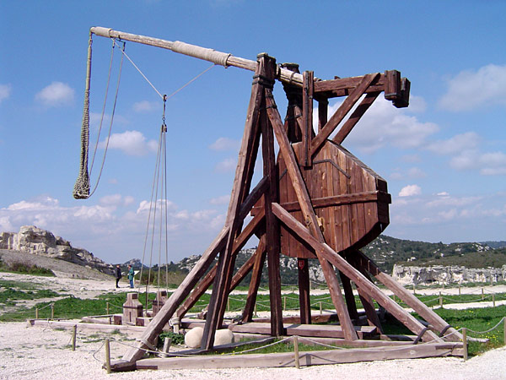

Visit www.punkinchunkin.com to view some catapults.

Challenge
In a group (or by yourself), you will design, construct, test and evaluate a projectile launcher that launches a standard projectile to meet the specified flight criteria outlined below. Each catapult will be evaluated by comparing its performance to the expected results for an ideal projectile. As part of the project, you will prepare a report that outlines the design features of your catapult, provides analysis of its operation, and makes recommendations for its improvements.

Materials
- Construction materials, such as wood, plastic, cardboard, metal
- Elastic materials, such as elastic bands or springs
- Materials to attach parts together, such as tape, glue or fasteners
- Materials for the projectile (tennis ball)
Project Criteria
- The challenge is to construct a Projectile Launcher that launches the projectile to achieve maximum range

- Research, design, and construct your device.

- Prepare a written report about your project that includes:

  - An appropriate title and the identification of group members

  - A theory section including an overview of the laws and principles of the Dynamics and Momentum Units that apply to your catapult

  - A labelled design drawing of the device including:
- The design and construction obstacles you faced during this project
- How you overcame the obstacles

  - An pre-analysis that includes measurements or calculations of:
    - The average force applied to the projectile / object
    - The distance through which the force is applied
    - The time for which the force is applied

  - A theoretical calculation for the performance of your device that includes:
    - Average launch velocity
    - Its range
    - Its maximum height
    - Its flight time

Use Vernier Logger Pro or other appropriate device to compare your theoretical calculations with the actual values.

  - An evaluation of the projectile launcher’s performance and recommendations for its refinement

- If you do not test the device in front of the class, you must include a video submission, to be shown to the class. It should include:
- You / all group members must be visible in the video at some time
- The video should begin with an oral description of the steps
- Each step should be easily visible on the video as it occurs

