Understanding G-force
CBC News Posted: Feb 20, 2011 12:30 PM ET Last Updated: Feb 21, 2011 11:11 PM ET
Which event packs a higher G-force punch — a sneeze or a shuttle launch? Surprisingly, they ring in around the same, at about 3 gravities (Gs).
At the other end of the spectrum, however, is the football tackle, which ranges from about 20 to 180 Gs. The term "G-force" — used to measure force on the body when it is accelerated — has becoming increasingly more relevant in a widening range of fields.
The National Football League, for example, has announced plans to use sensor technology in players' helmets to measure the forces of hits sustained during play. The G-force threshold for most concussions is about 85 to 90 Gs. Multiple concussions can lead to long-term health effects including depression, memory loss and increased risk of Alzheimer's disease.
Measuring G-force in other sports such as hockey is a complex task.
Kim Gorgens, a neuropsychologist and professor at the University of Denver, says research into the subject is needed.
"I don't know of research with accelerometers in hockey helmets (though likely a matter of time) but my understanding is that the forces would be greater given the biomechanical forces involved — velocity is increased (players travel faster on skates than on foot) so deceleration would be increased — increasing G-force of impact," she said in an email.
Here is a chart measuring G-force impacts in incidents ranging from a shuttle launch to a football tackle.

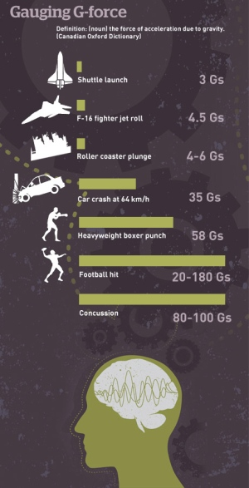

(Sources: Kim Gorgens, Popular Mechanics)

After reading the article, and examining the infographic, answer the following questions:

- Summarize the article, in 1 or 2 sentences.

- What is your response to the article? (How did it make you feel? Do you believe it? Is this something you have already known?)

- Use the equation: $F_{net}=9.8 x \# G's$, to find the force for each g in the infographic. The first one has been done for you.

Shuttle Launch: $F_{net}=9.8 x 3=29.4 N$

- After reading this article, do you feel that schools should allow students to play contact sports? Explain your answer.

