$$Unit 1$$

$$x= \frac{-b ± \sqrt{b^{2}-4ac}}{2a}$$

$$\frac{\sin{A}}{a}= \frac{\sin{B}}{b}= \frac{\sin{C}}{c}$$

$$c^{2}= a^{2}+ b^{2}-2abcosC$$

$$SOH CAH TOA$$

$${\overset{⃑}{v}}_{avg}= \frac{∆\overset{⃑}{d}}{∆t}$$

$$\overset{⃑}{a}= \frac{{\overset{⃑}{v}}_{2} - {\overset{⃑}{v}}_{1}}{∆t}$$

$$∆\overset{⃑}{d}= \left(\frac{{\overset{⃑}{v}}_{1} + {\overset{⃑}{v}}_{2}}{2}\right)∆t$$

$$∆\overset{⃑}{d}= {\overset{⃑}{v}}_{1}∆t + \frac{1}{2}\overset{⃑}{a}∆t^{2}$$

$$∆\overset{⃑}{d}= {\overset{⃑}{v}}_{2}∆t - \frac{1}{2}\overset{⃑}{a}∆t^{2}$$

$${\overset{⃑}{v}}_{2}^{2}={\overset{⃑}{v}}_{1}^{2} +2\overset{⃑}{a}∆\overset{⃑}{d}$$

$${\overset{⃑}{F}}_{g}=m\overset{⃑}{g}$$

$${\overset{⃑}{F}}_{net}=m\overset{⃑}{a}$$

$$F_{f}= μF_{n}$$

$${\overset{⃑}{v}}_{og}= {\overset{⃑}{v}}_{om} +{\overset{⃑}{v}}_{mg}$$

$$a_{c}= \frac{v^{2}}{r}$$

$$a_{c}= \frac{4π^{2}r}{T^{2}}$$

$$a_{c}=4π^{2}rf^{2}$$

$$F_{c}=ma_{c}$$

$$F_{c}= \frac{mv^{2}}{r}$$

$$F_{c}= \frac{m{4π}^{2}r}{T^{2}}$$

$$F_{c}=m4π^{2}rf^{2}$$

$$F_{gx}=mg sinθ$$

$$F_{gy}=mg cosθ$$

$$μ=tanθ$$

$$Unit 2$$

$$\overset{⃑}{p}=m\overset{⃑}{v}$$

$$\overset{⃑}{F}= \frac{∆\overset{⃑}{p}}{t}= \frac{m∆\overset{⃑}{v}}{t}=m\overset{⃑}{a}$$

$$\overset{⃑}{J}= ∆\overset{⃑}{p}= \overset{⃑}{F}∆t=m∆\overset{⃑}{v}$$

$$∆{\overset{⃑}{p}}_{total}=0$$

$${\overset{⃑}{p}}_{total i}= {\overset{⃑}{p}}_{total f}= {\overset{⃑}{p}}_{cm}$$

$$F=kx$$

$$W= \overset{⃑}{F}∆\overset{⃑}{d}=F∆d cosθ$$
$$E_{k}= \frac{1}{2}mv^{2}$$

$$E_{e}= \frac{1}{2}kx^{2}$$

$$E_{k}= \frac{p^{2}}{2m}$$

$$E_{total}= E_{p} +E_{k}$$

$$∆E_{g}=mg∆h$$

$$P= \frac{E}{t}=Fv$$

$$v_{1f}= v_{1o}\left(\frac{m_{1} - m_{2}}{m_{1} + m_{2}}\right)$$

$$v_{2f}= v_{1o}\left(\frac{{2m}_{1}}{m_{1} + m_{2}}\right)$$

$$Unit 3$$

$$F_{g}= \frac{Gm_{1}m_{2}}{r^{2}}$$

$$g= \frac{Gm}{r^{2}}$$

$$v= \sqrt{\frac{Gm_{planet}}{r}}$$

$$v= \frac{2πr}{T}$$

$$F_{e}= \frac{kq_{1}q_{2}}{r^{2}}$$

$${\overset{⃑}{F}}_{e}=q\overset{⃑}{ε}$$

$$ε= \frac{kq_{m}}{r^{2}}$$

$$qV=qεd$$

$$W=qεd=F_{e}∆d$$

$$∆E_{e}=qεd= ∆E_{k}=W$$

$$∆V= \frac{∆E_{e}}{q}= \frac{W_{12}}{q}$$

$$\frac{1}{2}mv^{2}=q\left(V_{1} - V_{2}\right)$$

$$E_{e}= \frac{kq_{1}q_{2}}{r}$$

$$ε= \frac{V}{d}$$

$$V= \frac{kq}{r}$$

$$F_{m}=BIL sinθ$$

$$B= \frac{μI}{2πr}$$

$$B= \frac{μNI}{2r}$$

$$B= \frac{μNI}{L}$$

$$F_{m}=qvB sinθ$$

$$m= \frac{qB^{2}r^{2}}{2V}$$

$$F_{m}= \frac{μ_{o}I_{1}I_{2}L}{2πr}$$

$$Unit 4$$

$$T= \frac{1}{f}$$

$$f= \frac{1}{T}$$

$$v=fλ$$

$$c=fλ$$

$$n= \frac{c}{v}$$

$$n_{1}\sin{θ_{1}= n_{2}\sin{θ_{2}}}$$

$$\frac{n_{film}}{n_{air}}= \frac{λ_{air}}{λ_{film}}= \frac{v_{air}}{v_{film}}$$

$$mλ = \left|PS_{2} -PS_{1}\right|$$

$$mλ=d sinθ$$

$$mλ= \frac{dx_{m}}{L}$$

$$Thin Films$$
$$Reflection$$
$Constructive$ $t = \frac{λ}{4}, \frac{3λ}{4}, …$

$Destructive$ $t = 0, \frac{λ}{2}, λ, …$

$$Transmission$$
$Constructive$ $t = 0, \frac{λ}{2}, λ, …$

$Destructive$ $t = \frac{λ}{4}, \frac{3λ}{4}, …$

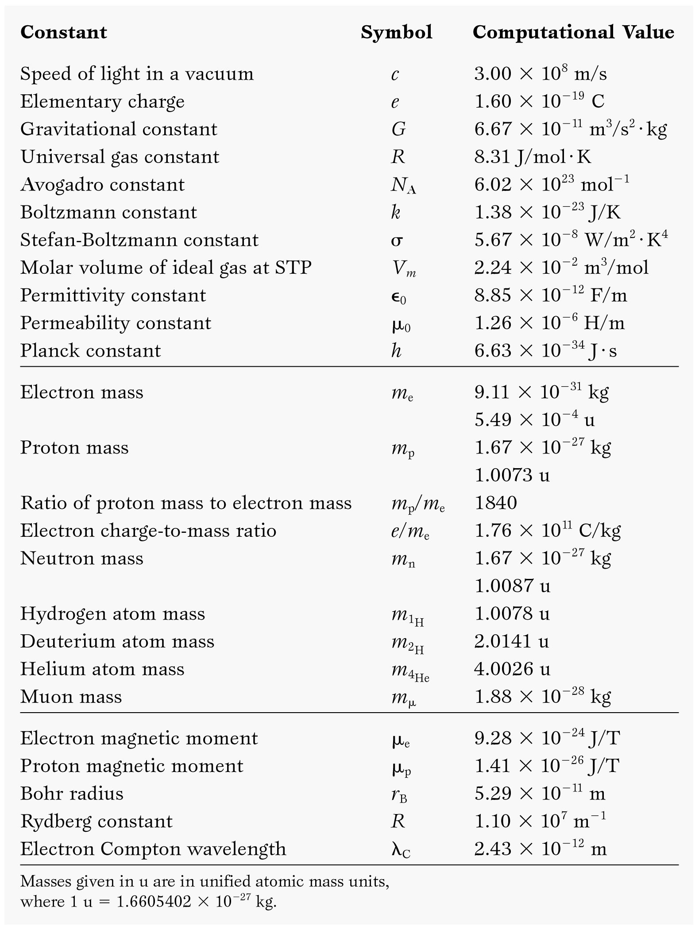

Acceleration due to gravity on Earth g 9.8 m/s²
Radius of the Earth r_{E} 6.38 x 10⁶ m
Mass of the Earth m_{E} 5.98 x 10²⁴ kg
Newton’s Universal Gravitation Constant G 6.67 x 10⁻¹¹ Nm²/kg²
Coulomb’s Constant k 9.0 x 10⁹ Nm²/C²
Charge on an electron / proton q_{e} 1.602 x 10⁻¹⁹ C
Coulomb C 6.242 x 10¹⁸ electrons
Permeability Constant µ_{o} 4π x 10⁻⁷ Tm/A
Speed of Light (in a vacuum) c 2.998 x 10⁸ m/s

1 nm = 1 x 10⁻⁹ m 1 µm = 1 x 10⁻⁶ m

