Station # 1: Levers
Location: Classroom
- Build each class of lever. For each one, measure the load arm and effort arm. Draw the diagrams below.

- Calculate the IMA for each lever.

- The efficiency equation is: $\% Efficiency= \frac{AMA }{IMA} x 100\%$. Describe how you would construct a lever that is more than 100% efficient.

Station # 2: More Levers
Location: Classroom
- Use the shovel and determine whether or not it is possible to use it as a 1st, 2nd and 3rd class lever. If a class of lever is possible, draw a diagram. Be sure to label the fulcrum, effort force and load force. If a class of lever is not possible, explain why.

Station # 3: Pulleys
Location: Classroom, at the laptop
- Work through the Pulley Lesson Powerpoint. Describe the difference between a movable and a fixed pulley.

- Construct a system of pulleys to reduce the force needed to lift the mass. Draw a diagram and label the fixed and movable pulley(s).

- As you add pulleys, what happens to the length of the string?

- Calculate the AMA and IMA for the pulley you constructed.

- Ms. Carew has a mass of 60 kg. How many support strings will she need to create a pulley system that will lift her with 1 kg? How do you know?

Station # 4: Inclined Planes
**The cart is ONLY for the crate, NOT for students**

Location: Wheelchair Ramp outside Mr. McMorrow’s classroom

- Use the Newton scale to lift the milk crate and cart up the stairs vertically. Record the force used and the height lifted

Force: _____ Height: _____

Find the work using the equation: Work = Force x Height

Now use the Newton scale to pull the milk crate and cart up the wheelchair ramp at a constant rate. Record the force and length.

Force: _____ Length: _____

Find the work using the equation: Work = Force x Height

- What do you notice about the work in each situation?

- What do you notice about the force and distance in each situation?

- What can you conclude happens to the distance as the force decreases?

- Calculate the AMA and IMA for the wheelchair ramp. How do the two compare?

Station # 5: Torque
Location: Hallway outside the classroom
- The load has a mass of 10 kg. Determine the mass that will lift the load, when placed on the ‘X’. When you have done the math, test your hypothesis.

- Were you correct? Why or why not?

- Determine the AMA and IMA of your lever.

- The efficiency equation is: $\% Efficiency= \frac{AMA }{IMA} x 100\%$. Determine the efficiency of your lever.

Station # 6: Gears
Location: Classroom
- Examine the wheel – how is a wheel like a lever?

- Use the red and blue gears (don’t pinch your fingers!). How can you tell which is the effort gear and which is the load gear?

- Determine the IMA for i) the red gear as the effort gear; ii) the blue gear as the effort gear.

- Which way gives a better advantage? Why might you want gears set up the other way?

- Read the ‘How Stuff Works’ article on gears.

What is the purpose of the gear teeth?

Examine the gear machine. Is there a worm gear present?

Station # 7: Levers in the Human Body
Location: Prep Room
- Read the article: Levers and Body Parts (http://www.biologycorner.com/worksheets/articles/levers_body.html).

On the skeleton identify the three classes of levers, the use of torque by the hamstrings, and how to carry heavy objects and reduce strain on the back. Now label these on the diagram(s) below:

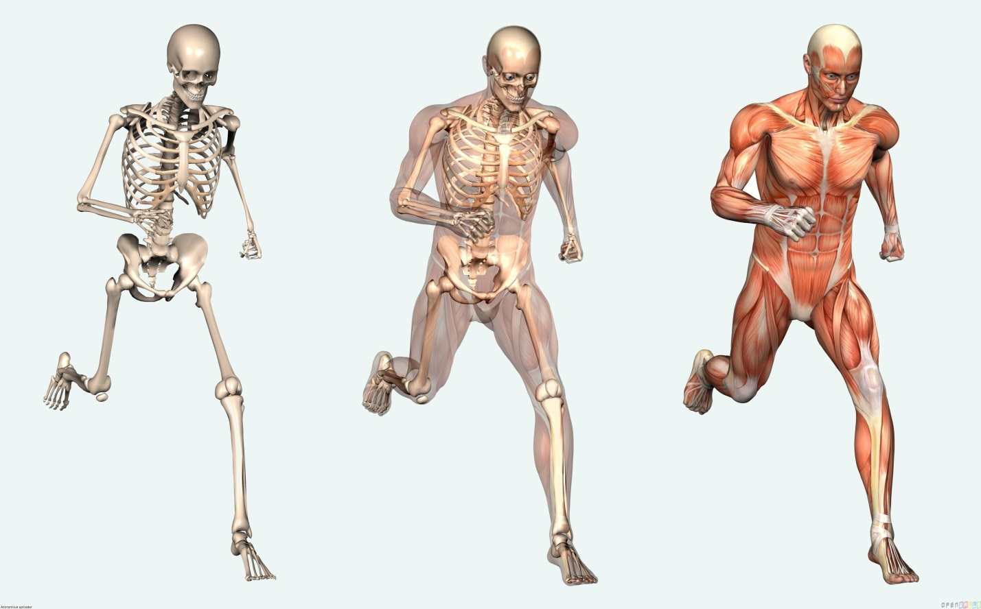

- Watch the video: Biomechanics of the Body – Levers (https://www.youtube.com/watch?v=ny8k7LUUIEk) and answer the questions below:

What class are most of the levers in the human body?

What advantage does this type of lever give?

Draw a diagram of the swimmer, and label the fulcrum, load force and effort force.

Consider the tennis player – explain why, using levers, taller players can generate faster serves.

- Watch one of the following videos from ESPN Sport Science: Boston Cannons’ Paul Rabil (lacrosse), Tim Burke’s Long Drive (golf), The Torque on Tiger (golf), Executing a Tailwhip (X games), Hitting a Softball (softball). Summarize the role levers and / or torque play in the sport.

