ENERGY AND SOCIETY SUMMATIVE TASK: OPTION #2

Rube Goldberg Project & Rubric

Reuben Lucius Goldberg was a Pulitzer Prize-winning artist that cartooned inventions putting an elementary challenge into a complicated and convoluted series of steps. The contraptions satirised the new technology and gadgets of the day. Using simple machines and household items already in use, the complex and wacky inventions always got the job done.
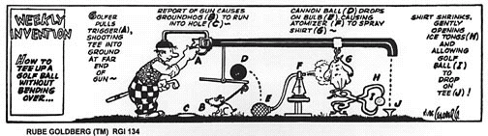
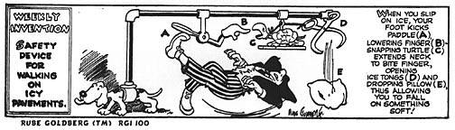
Rube Goldberg Machines have become an annual competition and a national craze. The idea of Rube Goldberg machines have appeared in video games, movies (in Back to the Future, a Rube Goldberg machine feeds Doc’s dog Einstein) and board games. In the Hasbro board game, “MouseTrap”…you start by turning the crank, that rotates the gears, that push the lever, that moves the shoe, that kicks the bucket, that sends the ball down the stairs and into the gutter, that leads to the rod that releases a second ball, that falls through the bathtub and onto the springboard, that catapults the diver into the washtub, that causes the cage to fall and--whew!--hopefully, capture a mouse.

CHALLENGE
You and one partner will design a Rube Goldberg machine to pop a balloon, water a plant, crack an egg into a frying pan (or other task that has been approved by Ms. Carew) using at least 5 steps. The machine should use at least 3 different types of energy.
DESIGN STRATEGY
Start with how you are going to finish your project. Perhaps a string is going to pull something. Work your way backwards from there. How is the string going to be pulled? Maybe a weight will pull it? Or a mousetrap. Yeah... a mousetrap! How will the mouse trap be triggered? You see the pattern? Come up with more than one way to "finish" the machine. Perhaps a lever arm will be used in place of the string to "finish" the machine. Now begin to think backwards as to how the lever arm will be moved. It is very important that the machine be built on a stand. A stand will make sure that everything is in its proper place when the device is set up and will force your machine to work within it's boundaries. Finally, the most important step in the process…Test everything!

VIDEO SUBMISSION

A video submission is expected. It should include:
- Both group members must be visible in the video at some time
- The video should begin with an oral description of the steps
- Each step should be easily visible on the video as it occurs

WRITTEN SUBMISSION
Along with a video of your completed Rube Goldberg Machines you will submit the following:
- A written description of each step in your machine, including energy transformations occurring, simple machine(s) used
- A calculation showing the gravitational potential energy, the total energy of the system and the speed of the object at one point
- A detailed, labelled drawing / diagram of your machine (it can be computer generated)
- A log of trials, the outcomes of the trials and how you adapted your machine based on the outcome

