SPH 4C

GRAPHING INVESTIGATION
THE MOTION OF A REMOTE CONTROL CAR

Purpose: The purpose of this investigation is to determine the speed and velocity of a remote control car using calculations and compare it to graphing distance and displacement versus time.

Materials:
- 4 Stopwatches
- Remote control car
- Measuring tape

Procedure:
- Mark a start line on the floor using masking tape or chalk.
- Measure out a distance of 5m and 10m from the start line and mark each measurement on the floor.
- Have one person stand at the 5 m mark with a stopwatch to measure the time of the car on the way there.
- Have one person stand on the 10 m mark with a stopwatch to measure the time of the car on the way there.
- Have one person stand on the 5 m mark with a stopwatch to measure the time of the car on the way back.
- Have someone stand at the finish line with a stopwatch to measure the time of the car on the way back.
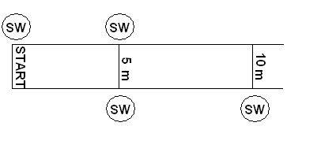

- Place the remote control car at the start line.
- On the count of “3-2-1-GO!” everyone will start his or her stopwatches and the driver will begin driving the car. Once the car reaches the 40 m mark, the driver will do a U-turn and drive the car back towards the finish line.
- As the car passes each measured mark on the floor, the person with a stopwatch will stop the time.
- Record the times in the chart below.

Observations:
Time  (s) | Distance  (m) | Displacement  (m [forward])
 | 0 | 0
 | 5 | 5
 | 10 | 10
 | 15 | 5
 | 20 | 0

Calculations:
- Calculate the speed of the car at each measured interval.
- Calculate the velocity of the car at each measured interval.

Analysis:
- Plot a graph of the distance of the car vs. time.
- Calculate the slope of the line of best fit.
- Plot a graph of the displacement of the car vs. time.

Questions:
- What does the slope on a distance-time graph represent?
- State some reasons why the dots do not form a perfectly straight line.
- Compare the speed of the remote control car that your group used to the remote control car that other groups used. Are the speeds the same? Why or why not?
- What quantities are measured by a car’s odometer and speedometer?
- What instrument would your car need to measure the velocity?
- Why do cars not have a “velocity-o-meter”?

