SPH 4C
INTRODUCTION UNIT INVESTIGATION

The period of a pendulum is defined as the time that the pendulum takes to complete one full cycle.
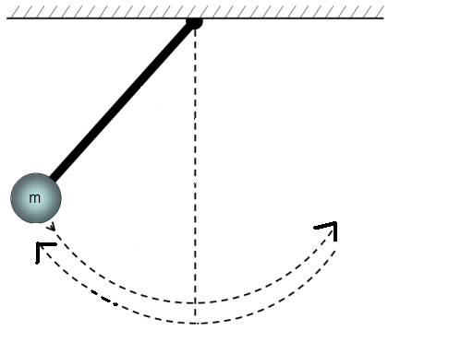

The object of this investigation is to determine the effect length and mass have on the pendulum.

Materials: stopwatch, string, various masses

Procedure:
- Hang a mass on a pendulum. Measure the length of the pendulum to the centre of the mass.
- Pull the mass to one side and measure the period of the pendulum by timing 10 swings.
- Record the time for 10 swings in the chart and then divide by 10 to measure the period of one swing. (This increases the accuracy)
- Replace the mass with a different mass and repeat step 2 and 3 keeping the length of the pendulum constant as well as the angle that the mass is pulled to one side.
- Repeat step 4 again for a different mass.
- Repeat steps 1-5 for three different lengths of pendulums but keeping the mass constant as well as the angle that the mass is pulled to one side.

Observations:
Table 1: Varying Mass Length of String: ___________
Mass (kg) | Time for 10 cycles (s) | Period (s) | Accepted Value (s)

Table 2: Varying Length Mass Used: ________________
Length (m) | Time for 10 cycles (s) | Period (s) | Accepted Value (s)
Analysis:
- Graph Period (s) vs. Mass (kg)
- Graph Period (s) vs. Length (m)
- Calculate the accepted value of the period using the equation
$T=2π\sqrt{\frac{L}{g}}$

Where T is the period (in seconds)
L is the length of the pendulum (in metres)
g is the gravitational constant 9.8 m/s²

NOTE: Because g only has 2 significant digits, round your final answers for T to only have 2 significant digits as well.

Error Analysis:
- What were the major sources of error?
- How do your experimental values of the period compare with the accepted values?
- How would you improve this experiment to reduce the error?

Discussion Questions:
- What do your graphs tell you about the effect of mass and length on the period of a pendulum? What other variables do you think might effect the period of a pendulum?
- How would the period of a pendulum compare if this experiment was performed on the moon. (Hint: g_{moon} = 1.6 m/s²)
- The accuracy of a grandfather clock is adjusted by moving the weight up and down on the pendulum, changing its effective length. If you notice that your grandfather clock is always behind, what do you need to do so that it keeps accurate time?
- Many watches today are digital with a small battery that provides the energy. Research to determine what is vibrating to keep accurate time.

Conclusion:

…yes…you need to write one!

