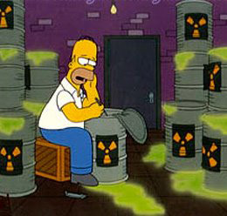
Nuclear Energy Worksheet
- Which elements are represented by each of the following?
  - ${}_{17}^{35}X$
  - ${}_{86}^{222}X$
  - ${}_{4}^{9}X$
  - ${}_{92}^{238}X$
  - ${}_{101}^{256}X$

- Write the chemical equation for each of the following parent nuclei undergoing alpha decay.
  - ${}_{92}^{238}U$
  - ${}_{96}^{248}{Cm}$
  - ${}_{29}^{64}{Cu}$
  - ${}_{4}^{8}{Be}$
  - ${}_{84}^{214}{Po}$

- Write the chemical equation for each of the following parent nuclei undergoing beta decay.
  - ${}_{15}^{32}P$
  - ${}_{16}^{35}S$
  - ${}_{8}^{19}O$
  - ${}_{82}^{212}{Pb}$
  - ${}_{90}^{131}{Th}$

- Write the chemical equation for each of the following parent nuclei undergoing gamma decay.
  - ${}_{10}^{19}{Ne}$
  - ${}_{11}^{22}{Na}$
  - ${}_{24}^{46}{Cr}$
  - ${}_{93}^{239}{Np}$
  - ${}_{38}^{90}{Sr}$

