NEWTON IN 2-D, INCLINED PLANES, PULLEYS COLLABORATIVE PROBLEMS

F_{net}

m₂
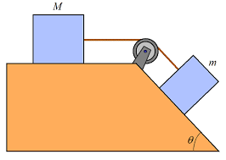
θ₃
θ₁
m₃
m₁

Determine tension on each rope and the acceleration of the system.
Note: The tension on each rope will be in terms of m₁.

Given:
m₂ is half of m₁;
m₃ is five times m₁;
θ₁ = 40.0º;
θ₃ = 50.0º;
µ_{k} = 0.056

- ONLY TO BE ATTEMPTED WHEN YOU HAVE COMPLETED #1.

A 4U physics student, leaving on a March Break holiday, pulls a 35.0 kg suitcase with an acceleration of 0.15 m/s² by pulling on a strap at an angle θ above the horizontal. The student pulls on the strap with a force of 55.0 N. The force of friction, opposite to the horizontal motion of the suitcase, is 25 N.

- What is the value of θ? (HINT: $\tan{θ}= \frac{\sin{θ}}{\cos{θ}}$ )

- What normal force does the ground exert on the suitcase?

