MAPLE SYRUP UNIT PRACTICE TEST

Knowledge & Understanding /21 Application /23 Communication /18 Thinking & Inquiry /16

Knowledge & Understanding (21 Marks)

- In the chart below, identify each tool and describe how it is used when making maple syrup. (8 marks)
Name | Picture | How is this tool used?
 | 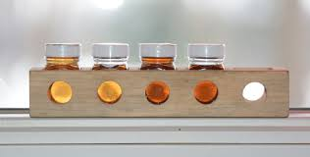
 | 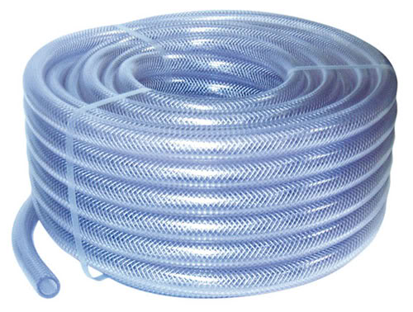
 | 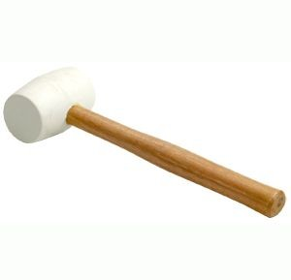

- What is marketing and why is it important in green industries? (3 marks)

- The chart below has pictures of the maple syrup process. Describe what is happening at each step and then put the pictures in the correct order (1 through 5). (10 marks)

Picture | Description | Step Number
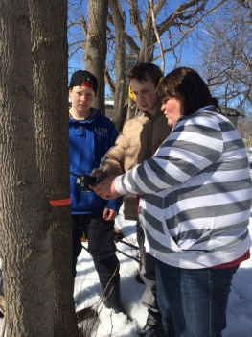
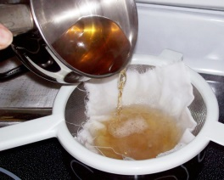
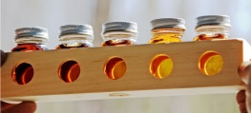
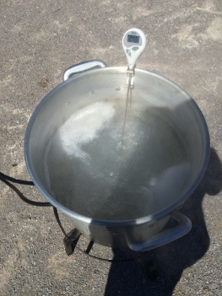
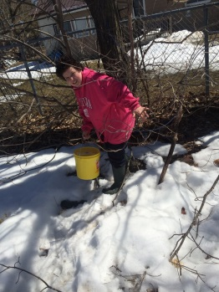

Application (23 Marks)

- Water boils at 213ºF today.
- At what temperature will the sap become maple syrup? (2 marks)

- What happens if the sap is not hot enough? (2 marks)

- What happens if the sap is too hot? (2 marks)

- a) How many litres of sap are needed to make one litre of syrup? (1 mark)

b) Why should you not boil maple syrup in your house? (2 marks)

- On the diagram below: (4 marks)
- Write the name of the tree we tap for maple syrup
- Label how wide a tree must be to tap
- Draw a side view of the hole you would drill
- Label how deep the hole must be
- Use the rule of 86 to predict the number of litres of sap to produce 1 litre of maple syrup, if the syrup has a sugar content of:
- 2%

- 6%

- Use the 40:1 Rule to predict how many litres of syrup will be produced by 350 L of sap.

- Why did we put dowels in the holes when we removed the spiles? (2 marks)

- Explain what grading is and why it is important when producing maple syrup. (4 marks)

Communication (18 Marks)

- Would you ever want to make maple syrup on your own? Give two reasons why or why not. (4 marks)

- Examine the following label, and identify three things that are missing from it. For each thing that is missing, explain why it is important. (6 marks)

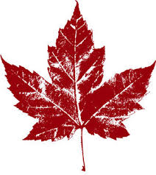
Maple Syrup

Produced by Ms. Carew

- On the trees below, draw the two types of pail set-ups we had. Beside each one, write a pro and con. (8 marks)

Thinking & Inquiry (16 Marks)

- Look at the picture below. Would you tap this tree next spring? Why or why not? (4 marks)
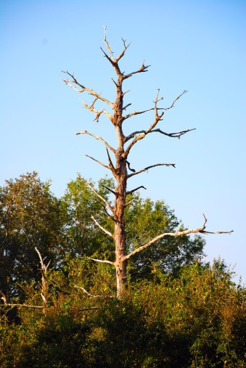
- Look at the picture below. Explain what’s wrong with this spile and tubing set-up and how you would change it. (4 marks)
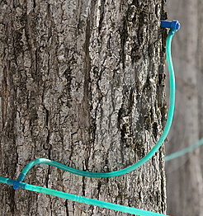

- You are making maple syrup, and when you check your sap buckets, you notice that the lids have blown off and there many sticks and leaves in the sap. What should you do to keep the lids in place and how will you remove the sticks and leaves? (2 marks)

- Your friend is making maple syrup this year. They say that although they have followed all of the proper steps, their maple syrup is very cloudy, with lots of sugar sand. What would you suggest to help your friend improve their maple syrup? (2 marks)
- Use the picture of the tree below to help you explain why spiles have holes in the bottom, and not the top. (4 marks)

