KINEMATICS UNIT ASSIGNMENT

- The figure shown below shows four possible ways of indicating speed limits on roads. Which one communicates the information best? Why?
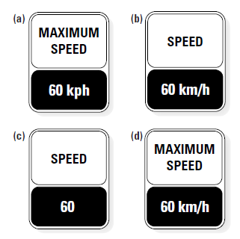

- When characters in cartoons run off the edge of a cliff, they hang suspended in the air for a short time before plummeting. If cartoons obeyed the laws of physics, what would they show instead?

- Describe why the topic of acceleration has more applications now than in previous centuries.

- The Official Driver’s Handbook states that the minimum safe following distance is the distance a vehicle can travel in 2.0 s at a constant speed. Car drivers and motorcycle riders can follow the two-second rule for following other vehicles at a safe distance. In this question, assume two significant digits.

  - At 17 m/s (60 km/h), how far can a vehicle travel in 2.0 s?

  - Repeat (a) for a speed of 28 m/s (100 km/h).

  - People who fail to follow this basic rule, called “tailgaters”, greatly increase their chances of an accident if an emergency occurs. Explain whether you think tailgaters should or should not be fined for dangerous driving.

But truck drivers have a different rule. They must maintain a distance of at least 60 m between their truck and other vehicles while on a highway at any speed above 60 km/h (unless they are overtaking and passing another vehicle).

  - Compare the two-second rule values in (a) and (b) to the 60 m rule for trucks. Do you think the 60 m rule is appropriate? Justify your answer.

  - Big, heavy trucks need a long space to slow down or stop. One of the dangerous practices of aggressive car drivers is cutting in front of a truck, right into the supposed 60 m gap. Suggest how to educate the public about this danger.
- From her home, Jennifer travels 1700 m [E], to school. At lunch, she travels 2000 m [W] to go to a restaurant. After, she returns to school. At the end of the school day, she travels 500 m [W], to her part-time job.

- Draw a diagram of Jennifer’s travels.

- Determine her final displacement.

- If it took her 7.5 hours to get from her home to her part-time job, what was her velocity?

- A cyclist is travelling with a velocity of 10.0 m/s [E]. Thirty seconds later, the cyclist is travelling with a velocity of 1.2 m/s [W]. Determine the cyclist’s acceleration.

- A person jumps off a high diving board. If they enter the water in 0.75 seconds, what is their final speed?

- Superman is travelling through the air. He accelerates at a rate of 12.5 m/s², in 3.0 seconds, and is travelling 84.5 m/s after his acceleration. Determine Superman’s initial speed.

