Seven-year-old gets 3D-printed Iron Man prosthetic from Robert Downey Jr.
by James Vincent@jjvincent Mar 13, 2015, 5:24am EDT

Everyone knows that some superheroes are made, not born. You don't need to be from another planet or get bitten by anything radioactive to become one — you just need the right gear. In this video from non-profit prosthetic maker Limbitless Solutions, Robert Downey Jr. (aka Iron Man) steps in to demonstrate this first hand. Downey delivers a 3D-printed prosthetic arm modeled after his character's super-powered gauntlets to Alex, a 7-year-old born with a partially developed right arm. There's no Arc Reactor in sight, mind you, but even heroic kids needs to take it slowly when dealing with Iron Man's gear.

3D PRINTING HELPED BRING DOWN THE COST OF ALEX'S IRON MAN PROSTHETIC TO JUST $350

Limbitless Solutions is a project run out of the University of Central Florida by Albert Manero, a doctoral student in mechanical engineering and a Fulbright scholar. He and the other Limbitless volunteers use new technology like 3D printing to create cheap, electronic prosthetics for children, giving away the results for free. Often, young people don't get the prosthetics they really need simply because it's too expensive to buy designs that won't fit in a year's time. That's not the case with Limbitless' work, however. While conventional electronic prosthetics cost tens of thousands of dollars, Alex's arm needed just $350 for materials. With prices like this, the Limbitless team were able to afford the arm just by pooling their "coffee money." If you feel like donating yourself, there's a link to do so in the top right of their site.

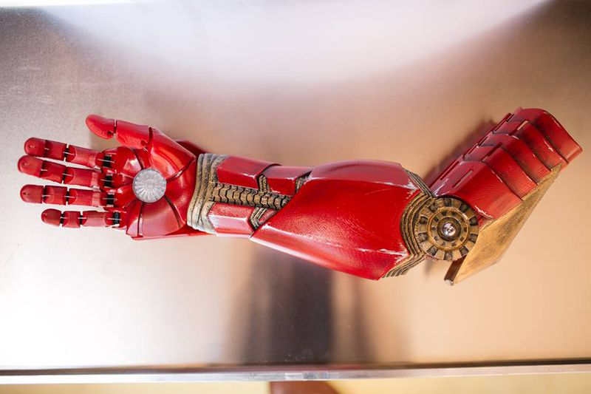
A close-up of Alex's new Iron Man gauntlet. (Limbitless Solutions)

