**GEOMETERY PROBLEM SET – DO YOUR WORK ON ANOTHER PAGE!!**

1. Abdi works in the forestry industry. His truck can carry 21 logs, stacked as shown. Each log has an average length of 15 m and an average circumference of 2 m. Determine the total volume of wood Abdi can haul in one load, to the nearest cubic metre.

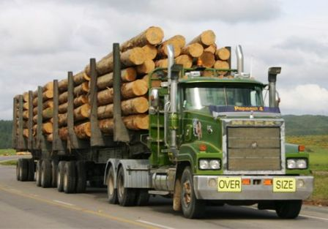

1. A cylindrical wheel of cheese is divided into 6 identical wedges, as shown here. Find the area of wrapping needed for one wedge of cheese.



1. John has 175 ft. of fence, and wants to enclose the largest area possible.
2. Determine the area of the circle it can enclose
3. John decides that the fence cannot be a circle. Find the dimensions and area of the largest rectangular area it can enclose.
4. John decides he doesn’t want to measure fractions of an inch. Find the dimensions and area of the largest rectangle that can be enclosed with whole number sides.
5. Michelle wants to build a glassed-in hot tub room onto the side of her house. For zoning reasons, it can only cover an area of 55 m2. The wall of her house will be one side of the room.
6. Determine the dimensions and perimeter if the room is a rectangle, and your answers can only be whole numbers. Include your chart.
7. Determine the dimensions and perimeter if the room is a rectangle, and your answers can be decimals.
8. Determine the dimensions and perimeter if the room is a semi-circle.
9. Michael wants to fence off an area of his property. He has 275 m of fence. He only needs to fence 3 sides, as he will use an existing fence for the fourth side.
10. Determine the dimensions and area if it is a rectangle, and the answers can only be whole numbers. Include your chart.
11. Determine the dimensions and area if it is a rectangle, and your answers can be decimals.
12. You work for the Healthy Snack Company. The company wants to sell their Healthy Snack in a small cylindrical tube, which holds a volume of 250 cm3. Determine the dimensions that will hold this volume with the smallest surface area. Include your chart below.
13. You are designing a new garden leaf bag. Each bag will be a rectangular prism, with a square base. The bag should be open at the top. Determine the dimensions that will give the maximum volume if the bag is to have a surface area of 3.00 m2. Include your chart below.