FROG DISSECTION QUESTIONS

BEFORE
- What is the purpose of dissecting the frog?

- List the materials.

DURING

- Is your frog male or female? How can you tell?

- Label the three diagrams of the frog.

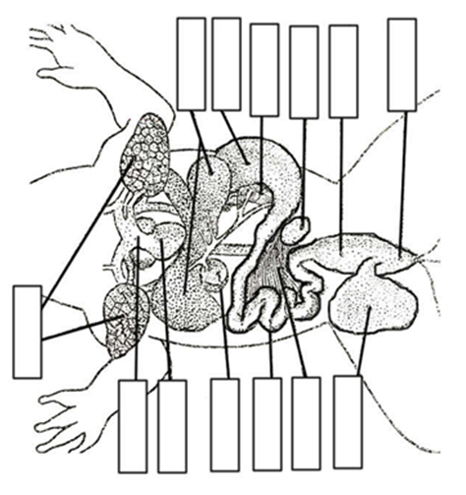

- Identify at least 3 organs in the frog and complete the chart below.

Frog Organ, and Organ System it is part of | Sketch of Frog Organ | Comparison between human and frog

AFTER
- Choose three organ systems that you are familiar with. For each one, describe how the frog organ system is similar to and different from the human organ system.

