Frog Dissection
Pictures: Modern Biology, Holt
Background:
As members of the class Amphibia, frogs may live some of their adult lives on land, but they must return to water to reproduce. Eggs are laid and fertilized in water. On the outside of the frog’s head are two external nares, or nostrils; two tympani, or eardrums; and two eyes, each of which has three lids. The third lid, called the nictitating membrane, is transparent. Inside the mouth are two internal nares, or openings into the nostrils; two vomerine teeth in the middle of the roof of the mouth; and two maxillary teeth at the sides of the mouth. Also inside the mouth behind the tongue is the pharynx, or throat.
In the pharynx, there are several openings: one into the esophagus, the tube into which food is swallowed; one into the glottis, through which air enters the larynx, or voice box; and two into the Eustachian tubes, which connect the pharynx to the ear. The digestive system consists of the organs of the digestive tract, or food tube, and the digestive glands. From the esophagus, swallowed food moves into the stomach and then into the small intestine. Bile is a digestive juice made by the liver and stored in the gallbladder. Bile flows into a tube called the common bile duct, into which pancreatic juice, a digestive juice from the pancreas, also flows. The contents of the common bile duct flow into the small intestine, where most of the digestion and absorption of food into the bloodstream takes place.
Indigestible materials pass through the large intestine and then into the cloaca, the common exit chamber of the digestive, excretory, and reproductive systems. The respiratory system consists of the nostrils and the larynx, which opens into two lungs, hollow sacs with thin walls. The walls of the lungs are filled with capillaries, which are microscopic blood vessels through which materials pass into and out of the blood. The circulatory system consists of the heart, blood vessels, and blood. The heart has two receiving chambers, or atria, and one sending chamber, or ventricle. Blood is carried to the heart in vessels called veins. Veins from different parts of the body enter the right and left atria. Blood from both atria goes into the ventricle and then is pumped into the arteries, which are blood vessels that carry blood away from the heart.
The urinary system consists of the frog’s kidneys, ureters, bladder, and cloaca. The kidneys are organs that excrete urine. Connected to each kidney is a ureter, a tube through which urine passes into the urinary bladder, a sac that stores urine until it passes out of the body through the cloaca. The organs of the male reproductive system are the testes, sperm ducts, and cloaca. Those of the female system are the ovaries, oviducts, uteri, and cloaca. The testes produce sperm, or male sex cells, which move through sperm ducts, tubes that carry sperm into the cloaca, from which the sperm move outside the body. The ovaries produce eggs, or female sex cells, which move through oviducts into the uteri, then through the cloaca outside the body.
The central nervous system of the frog consists of the brain, which is enclosed in the skull, and the spinal cord, which is enclosed in the backbone. Nerves branch out from the spinal cord. The frog’s skeletal and muscular systems consist of its framework of bones and joints, to which nearly all the voluntary muscles of the body are attached. Voluntary muscles, which are those over which the frog has control, occur in pairs of flexors and extensors. When a flexor of a leg or other body part contracts, that part is bent. When the extensor of that body part contracts, the part straightens.

Objectives:
• Describe the appearance of various organs found in the frog.
• Name the organs that make up various systems of the frog.
Purpose:
In this lab, you will dissect a frog in order to observe the external and internal structures of frog anatomy, and compare them to what you know about three organ systems in humans.
Materials:
• safety goggles, gloves, and a lab apron
• forceps / tweezers
• preserved frog
• dissecting pins (6–10)
• dissecting tray and paper towels
• dissecting scissors
• scalpel
• probe

Procedure:
- Put on safety goggles, gloves, and a lab apron.
- Place a frog on a dissection tray. To determine the frog’s sex, look at the hand digits, or fingers, on its forelegs. A male frog usually has thick pads on its "thumbs," which is one external difference between the sexes, as shown in the diagram below. Male frogs are also usually smaller than female frogs. Observe several frogs to see the difference between males and females.
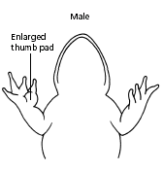 | 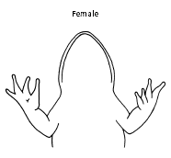
- Use the diagram below to locate and identify the external features of the head. Find the mouth, external nares, tympani, eyes, and nictitating membranes.
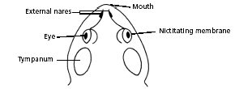
- Turn the frog on its back and pin down the legs. Cut the hinges of the mouth and open it wide. Use the diagram below to locate and identify the structures inside the mouth. Use a probe to help find each part: the vomerine teeth, the maxillary teeth, the internal nares, the tongue, the openings to the Eustachian tubes, the esophagus, the pharynx, and the slit-like glottis.
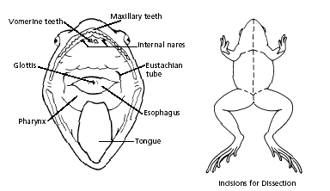
- Look for the opening to the frog’s cloaca, located between the hind legs. Use forceps to lift the skin and use scissors to cut along the center of the body from the cloaca to the lip. Turn back the skin, cut toward the side at each leg, and pin the skin flat. The diagram above shows how to make these cuts
- Lift and cut through the muscles and breast bone to open up the body cavity. If your frog is a female, the abdominal cavity may be filled with dark-colored eggs. If so, remove the eggs on one side so you can see the organs underlying them.
- Use the diagrams below to locate and identify the organs of the digestive system: esophagus, stomach, small intestine, large intestine, cloaca, liver, gallbladder, and pancreas.
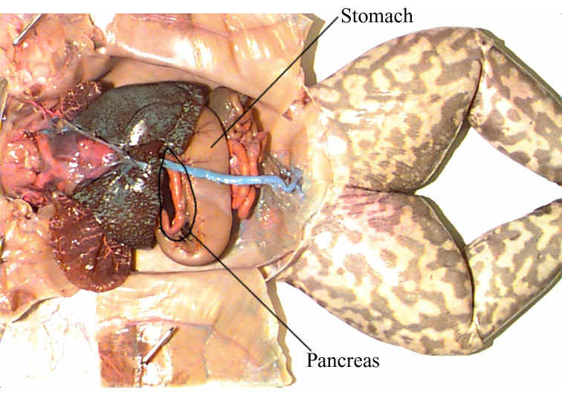
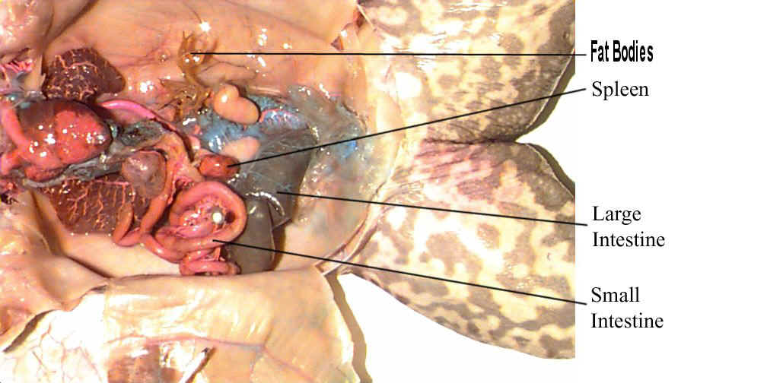

- Again refer to the diagram below to identify the parts of the circulatory and respiratory systems that are in the chest cavity. Find the left atrium, right atrium, and ventricle of the heart. Find an artery attached to the heart and another artery near the backbone. Find a vein near one of the shoulders. Find the two lungs.
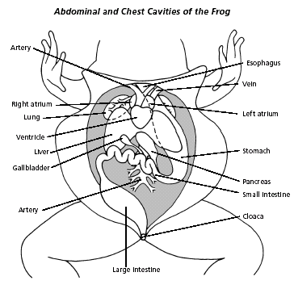

- Use a probe and scissors to lift and remove the intestines and liver. Use the diagram on the next page to identify the parts of the urinary and reproductive systems. Remove the peritoneal membrane, which is connective tissue that lies on top of the red kidneys. Observe the yellow fat bodies that are attached to the kidneys. Find the ureters; the urinary bladder; the testes and sperm ducts in the male; and the ovaries, oviducts, and uteri in the female.
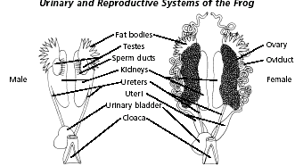
- Remove the kidneys and look for threadlike spinal nerves that extend from the spinal cord. Dissect a thigh, and trace one nerve into a leg muscle. Note the size and texture of the leg muscles.
- Dispose of your materials according to the directions from your teacher.
- Clean up your work area and wash your hands before leaving the lab.

