"... printing, gunpowder and the Mariner's needle [a magnet].
For these three have changed the whole face and state of things
throughout the world."
Francis Bacon (1561-1626)
English lawyer, philosopher and essayist.
In Novum Organum (1620).
Try these "busters" to exercise your brain ... they should help you grasp the concepts underlying the properties of magnetic fields, etc. To gain the maximum effect you should attempt to answer them before looking at the answers!

[1] A steady current flows in the circuit shown below. If a compass were placed beneath the circuit at points A, B and C what would you expect to observe in the way of deflection?
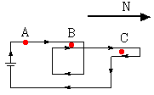

[2] Here's a strange one! The north pole of a compass needle is attracted to the north pole of the Earth. Since like poles are supposed to repel, how can that be? What's the explanation?

[3] ... and another! One of your friends says that when a compass is taken across the equator from the northern hemisphere to the southern hemisphere, the needle turns round and points the other way. Another friend says that's nonsense! What's your opinion?

[4] You have two bars of iron; one is magnetized while the other is not. If there are no other items or materials nearby that you could use, how could you tell which one is the magnet?

[5] The picture shows an end-on view of three parallel wires that are perpendicular to the page. In two of the wires the current is directed into the page; in the third it is out of the page. The two outermost wires are fixed but the middle wire is free to move.
Will it move? Explain.

[6] A so-called electromagnet can be made by wrapping a coil around a "core", e.g., of iron. When a current flows through the coil it produces a magnetic field that is intensified by the "core"; the resulting field could be as much as 100's or 1000's of times greater than without the "core". In the arrangements below
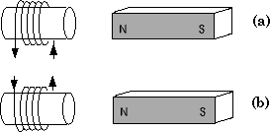
explain whether the electromagnets will be attracted towards or repelled from the permanent magnets on the right.

[7] For each electromagnet at the left of the picture, work out whether it will be attracted to or repelled from the nearby electromagnet on the right.
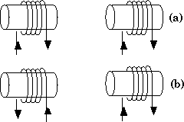

[8] If the earth's magnetism is assumed to originate from a large circular loop of current within the Earth, how is the plane of this loop oriented relative to the magnetic axis of the Earth and what is the direction of the current?

[9] The diagram shows 4 wires viewed end-on; they are long, straight and parallel to each other and their axes lie at the corners of a square. Each wire carries a current of the same magnitude. What is the direction of the current in each wire so that if any single current is switched off, the total magnetic field at the point P, the center of the square, is directed towards one corner of the square.
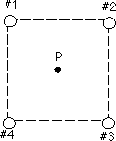
Explain your answer. Hint: there are 4 possible solutions ... see if you can get them all.

[10] The diagram shows 3 wires viewed end-on; they are long, straight and parallel to each other and their axes lie at the corners of a square. The currents in #1 and #2 are equal and directed into the page. If you want the magnetic field at the vacant corner to be zero can you figure out the direction and magnitude of the current in #3?
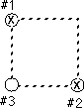
Explain your reasoning.

[11] You are given a length of wire, L, and you must bend it into the shape that gives the largest magnetic field at the center when a current passes along the wire; the choices are (a) a square, (b) a circle and (c) an equilateral triangle. Which would you choose?

The idea of brain "busters" was suggested to me by Ms. Lilian Jordan of Palm Beach Community College. The problems have been collected from a number of sources over the years, including myself(!) and inspired from ideas in texts such as "Conceptual Physics" by Paul Hewitt, "Peer Instruction" by Eric Mazur, "Physics for Scientists and Engineers" By Paul Tipler, "University Physics" by Hugh Young and Roger Freedman, "Physics" by John Cutnell and Kenneth Johnson, and "The Flying Circus of Physics" by Jearl Walker. I have adapted them to suit my courses.

ANSWERS
Answer [1]: First, we note that the compass needle with no current flowing will point N at points A, B and C. Second, we note that directly underneath the circuit at points A and B the magnetic field due to the current is directed towards the west although since in the vicinity of B there are two parallel wires carrying the same current, the field at B due to the current is twice as large as that at A. Third, since the currents passing down the two wires in the vicinity of C have the same magnitude but in opposite directions there is essentially no field due to the current at C. Using the principle that magnetic fields add vectorially we can see that the compass needle at C will still point N; at A and B the needle will be deflected towards the west but the deflection will be greater at B.

Answer [2]: Aha! The north and south poles of a compass needle are so named because they seek the north and south geographical poles of the Earth, respectively. If the north and south geographical poles of the Earth were marked by wooden posts and we had to paint on them the type of pole then the post near the north geographical pole would have an "S" on it and the post near the south geographical pole would have an "N" on it!
Look at it another way. Magnetic field lines "run" from N to S and if we look at the field lines around the Earth:
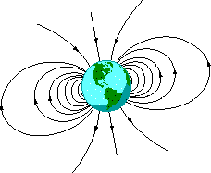
we see that they run from the south geographical pole to the north geographical pole. Therefore, what we call the north pole of the Earth is really a south pole, and vice versa! The north end of the compass needle simply "seeks" the north geographical pole.

Answer [3]: Tell friend number one that the lines of magnetic field around the Earth are continuous from pole to pole, see the figure in answer [2] above. Since a compass needle aligns itself with the magnetic field lines it will not flip round in direction as you cross the equator.

Answer [4]: Actually, it's very simple! Take one bar (#1) and put one end at the midpoint of the other (#2) so as to form a letter "T". If there is attraction then #1 is the magnet; if not, then #2 is the magnet!

Answer [5]: We know that two parallel wires with currents in the same direction attract each other while two parallel wires with currents in opposite directions repel each other. Therefore, the middle wire will be attracted to the wire on the left and repelled from the wire on the right. Since each of the fixed wires exerts a force to the left on the middle wire, the net force on the middle wire will be to the left. Thus, the middle wire will move to the left.

Answer [6]: We can determine the polarity of the electromagnets by using the right hand rule. For the electromagnet in figure (a), looking at the electromagnet from the position of the permanent, the current is going around counterclockwise so the field is outward, i.e., towards the right. Thus, the right end of the coil must be a north pole since magnetic field lines leave a north pole. So the left hand end must be a south pole.
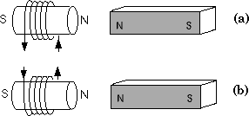
Similar reasoning can be used to identify the north and south poles of the electromagnet in figure (b). The results are shown in the figure above. Since the like poles of two different magnets repel each other and the dissimilar poles of two different magnets attract each other, we can conclude that in both arrangements, the electromagnet is repelled from the permanent magnet at the right.
Note that if the currents in either (a) or (b) were reversed then the poles of the electromagnet is reversed, and so we would have attraction.
One handy "device" I use to determine the polarity of the end of a coils is:
The direction of the current is shown by the arrows.

Answer [7]: We can determine the polarity of the ends of each electromagnet using the right hand rule; if the current is counterclockwise the lines are outward, i.e., a north pole, if the current is clockwise the lines are inward, i.e., a south pole. Thus, for example, the right end of the coil on the left in (a) must be a north pole. Similar reasoning can be used to identify the north and south poles of the other remaining electromagnets.
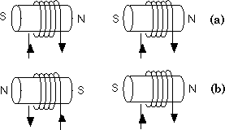
The results are shown in the figure above. Since the like poles of two different magnets repel each other and the dissimilar poles of two different magnets attract each other, we can conclude that the arrangement shown in (a) results in attraction; the electromagnets shown in arrangement (b) repel each other.

Answer [8]: If the Earth's magnetism is assumed to originate from a large circular loop of current within the Earth, the plane of the current loop must be perpendicular to the magnetic axis of the earth, as shown below.
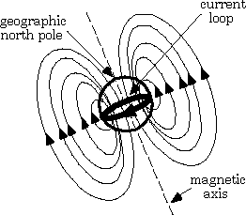
Since the lines of magnetic field flow inward towards the Earth's geographic north pole, by using the right hand rule we find that the current must flow clockwise when viewed looking down at the loop from the geographic north pole.

Answer [9]: The total magnetic field at the point P is the resultant of the magnetic field at P due to each individual wire. If the current in all four wires is directed into the page, then from the right hand rule, the magnetic field at P due to the current in #1 must point toward #4, the magnetic field at P due to the current in #2 must point toward #1, the magnetic field at P due to the current in #3 must point toward #2, and the magnetic field at P due to the current in #4 must point toward #3, as shown below.
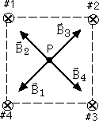
Since the current in all four wires has the same magnitude and all four wires are the same distance from the point P, each wire gives rise to a magnetic field at P of the same magnitude. When current is flowing through all four wires, the total magnetic field at P, then, is zero. If the current in any single wire is turned off, the total magnetic field will point toward one of the corners. For example, if the current in #1 is turned off, the resultant of B₂ and B₄ is still zero and the total magnetic field is B₃. If the current in #2 is turned off, then the total magnetic field is B₄, and so on.
However, this is not the only answer! You can achieve a similar result if the current in all four wires is directed out of the page. In fact, providing opposite wires along the diagonal have currents in the same direction (for example, #1 and #3 with outward currents and #2 and #4 with inward currents) the total magnetic field will point toward one of the corners when one of the currents is turned off.

Answer [10]: The currents in #1 and #2 produce the magnetic fields B₁ and B₂ at the empty corner, as shown in the drawing.
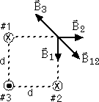
The directions of these fields can be obtained using the right hand rule. Since there are equal currents in #1 and #2 (= I) and since these wires are each the same distance d from the empty corner, B₁ and B₂ have equal magnitudes. The magnitude of the resultant field is given by:
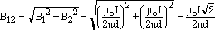
The current in #3 produces a field, B₃, at the open corner, and since the net field is required to be zero, B₃ must equal (B₁ + B₂) and be directed in the opposite direction. Therefore, by the right hand rule, the current in #3 must be directed upward. Also, since B₃ = (B₁ + B₂)
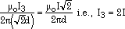

Answer [11]: Let's determine the magnetic fields in terms of the length L and current I. For the square,
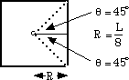 B_{square} = 4 × (μ_{o}I/4πR)(sinθ₁ + sinθ₂) = 3.60(μ_{o}I/L).
For the circle,
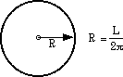 B_{circle} = μ_{o}I/2R = 3.14(μ_{o}I/L).
For the equilateral triangle,
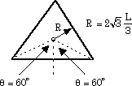 B_{triangle} = 3 × (μ_{o}I/4πR)(sinθ₁ + sinθ₂) = 4.30(μ_{o}I/L).
So, the equilateral triangle wins it (easily)!

