BIOLOGICAL DRAWINGS

Scientific drawings must be clear, well labeled and easy to understand. The following are some rules that will help you produce useful scientific drawings:

- Use blank white paper
- Use a sharp, hard pencil
- Plan to draw a large picture
- Leave space for labels on the right-hand side of the drawing
- Draw only what you see (do not try to add 3-D; our microscopes are 2-D)
- Do not sketch – use firm, clear lines
- Do not shade or colour – use stippling (dots) to indicate a darker area
- All drawings must be labeled fully in neat printing
- Label lines should be straight and parallel and run outside the drawing – use a ruler!
- List your labels in an even column down the right side
- Give the drawing a title and underline it
- Your name should be written on the bottom right-hand side of the diagram

BAD
Identify some of the mistakes in this diagram.
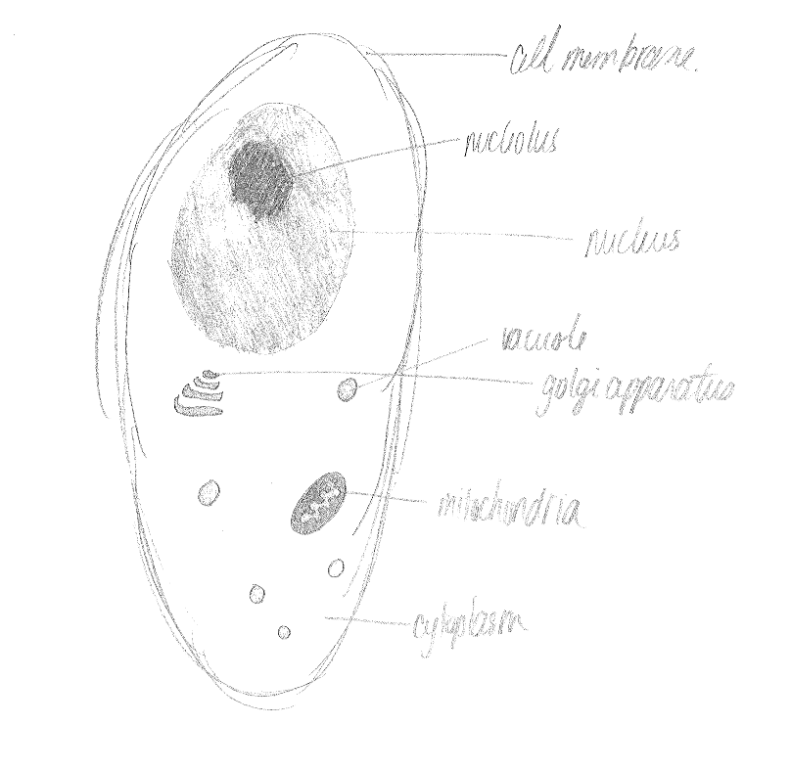

GOOD
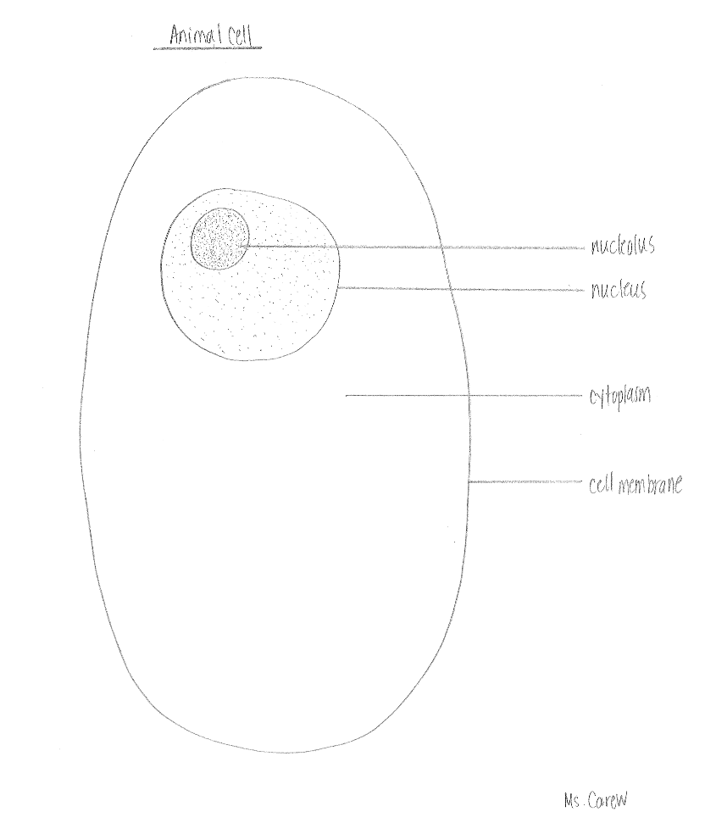

Your Task is to draw a proper biological diagram of your shoe. It will need a title, and you will need to label the sole, toe, heel, and laces (or zipper, velcro, ..). When you finish, have a partner peer-review it and hand your diagram and the peer-review in to the teacher.

