SPH 4C
ARE YOU READY?

- Figure 1 shows the motion of a car along a straight road. The images are taken at time intervals of 1.0 s. Describe the motion of the car using your vocabulary of motion.
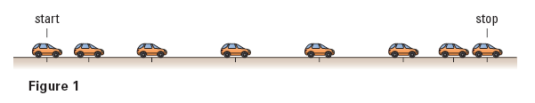

- The motion of three cars, L, M, and N are illustrated by the graphs shown below. Compare the times of travel and average speeds of the three cars.
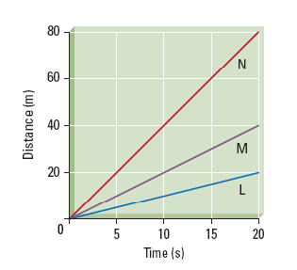

- Describe the sources of error you would encounter when measuring the length of this page with a metre stick.

- You are asked to calculate the speed of a jogger that runs beside you along a straight track. Describe how you would perform an experiment to calculate the required quantity.

- Describe your pen qualitatively and quantitatively.

- Draw three loonie-sized circles so they are spread out on the back of this piece of paper. Within each circle, write one of these topics: transportation safety, space exploration, and sports applications. For the topic, write around the outside of the circle the physics concepts and other facts that you already know about the topic.

- Suppose you are asked to test a new design for an artificial human arm. Describe three tasks you think the arm should be able to perform.

